**P.1. Introduction to SPIM**

**P.2. Question and Tasks**

3.1. The address where the code resides is 00400000

3.2. The instruction which is highlighted after every step show the next instruction. Because after that instruction performed, some values in the Register will change, or the instruction executed. Then the new instruction will be highlighted to determine the next execution.

3.3. The location in memory (in hex): 6c6c6548 4d202c6f 0a535049

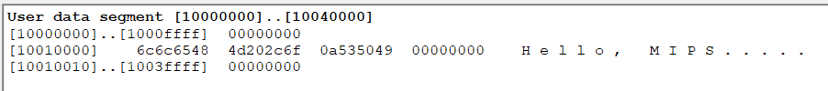

3.4.

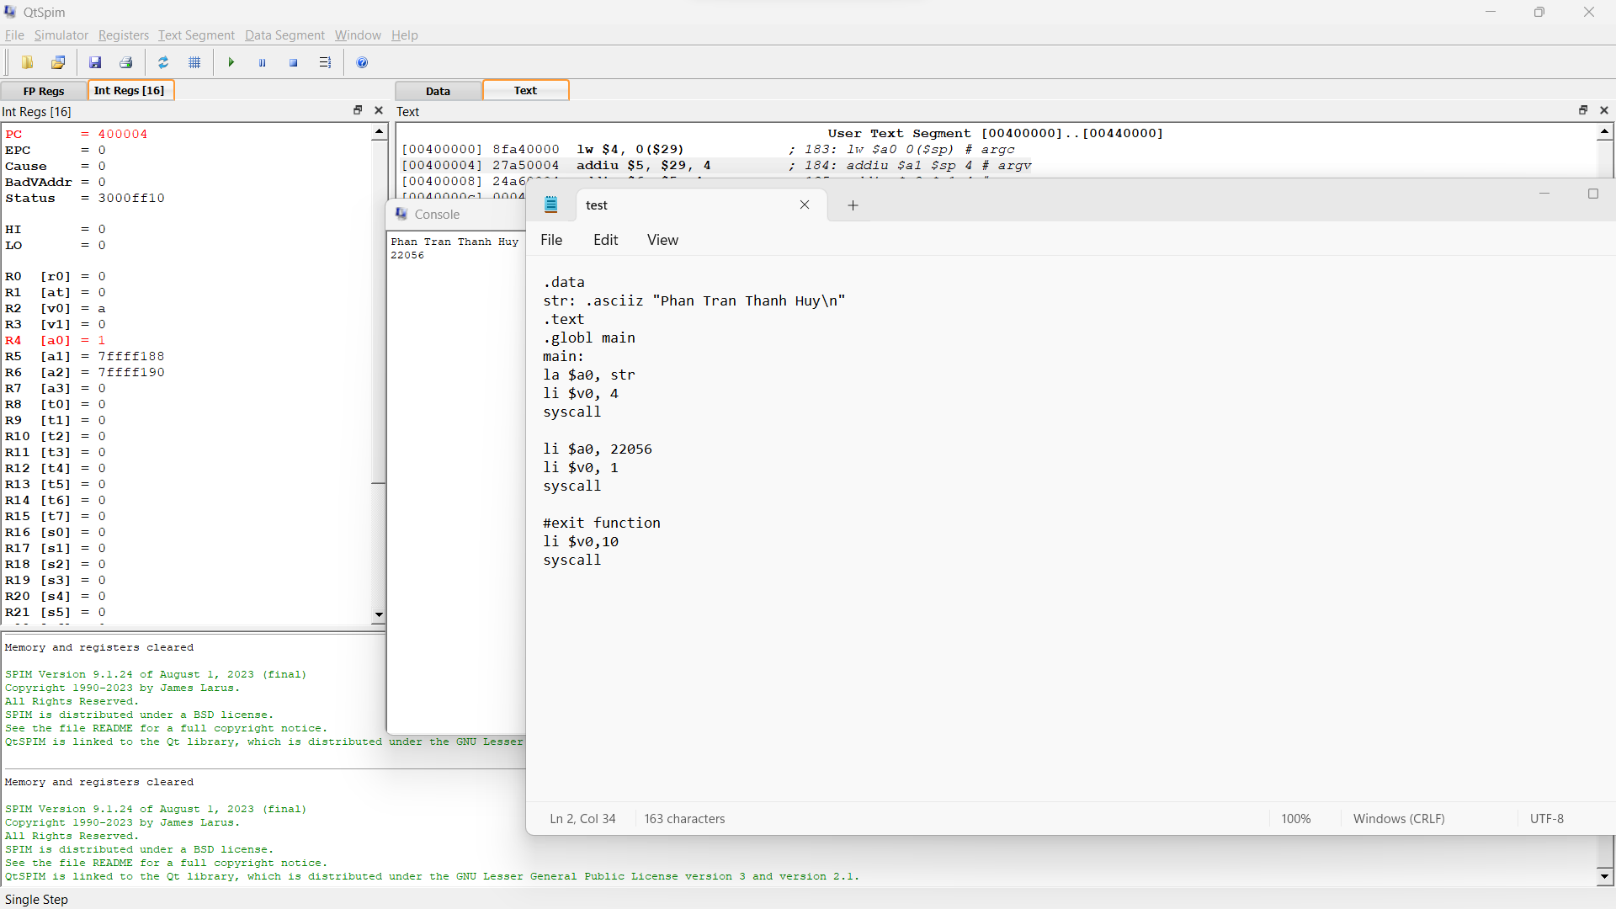

4.1. 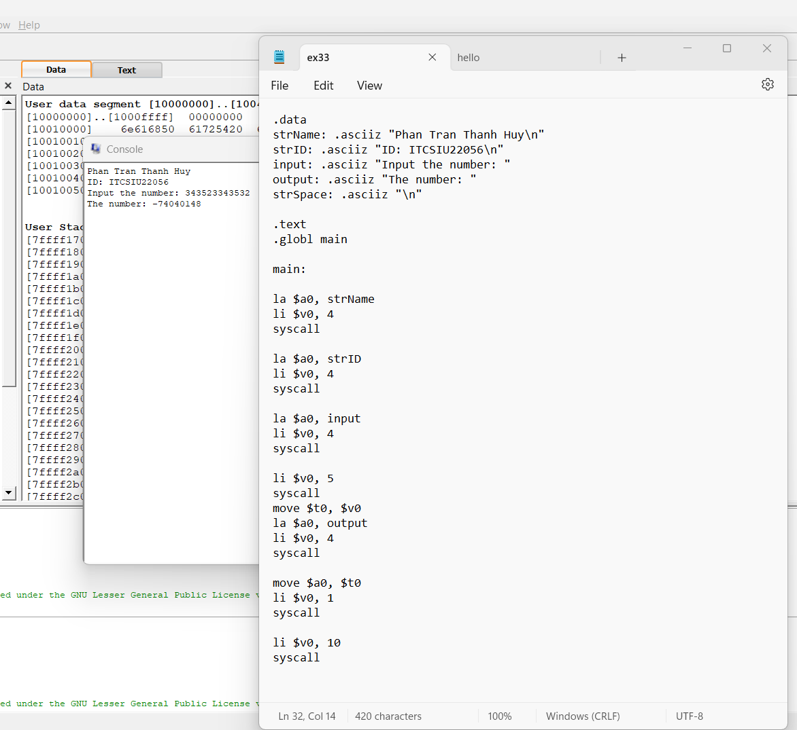

The output is not correct.

Because the input number is out of range the integer limit

4.2.

We apply the calculation:

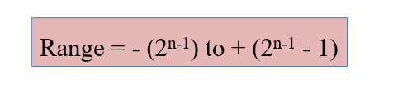

So the maximum and minimum input values that program can calculate correctly is: -2147483648 to 2147483649

4.3. 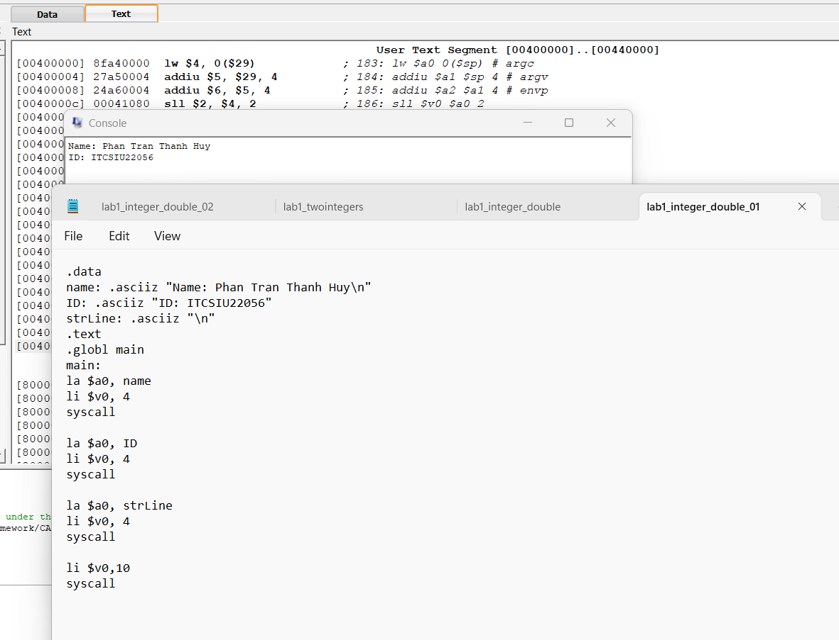

4.4.

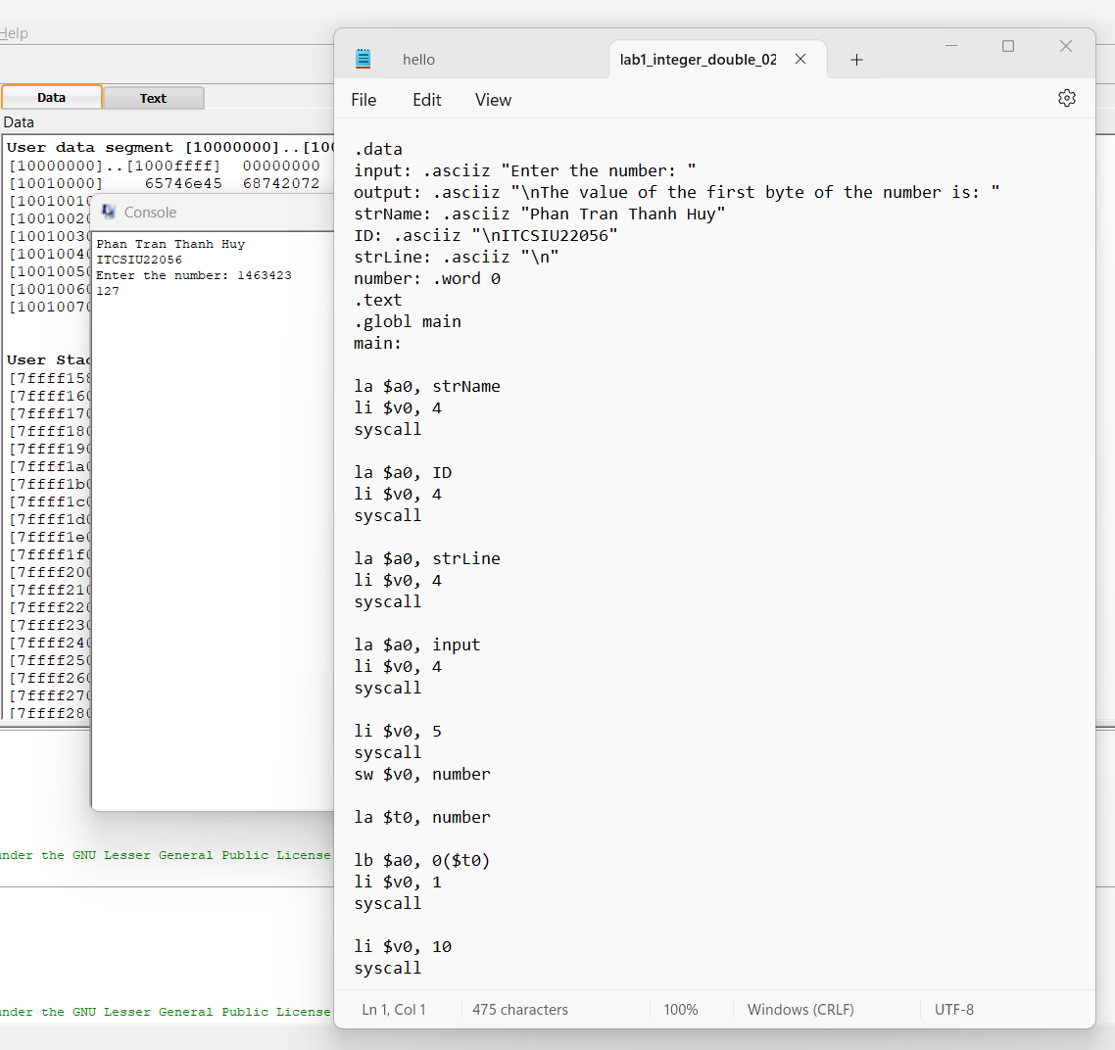

5.

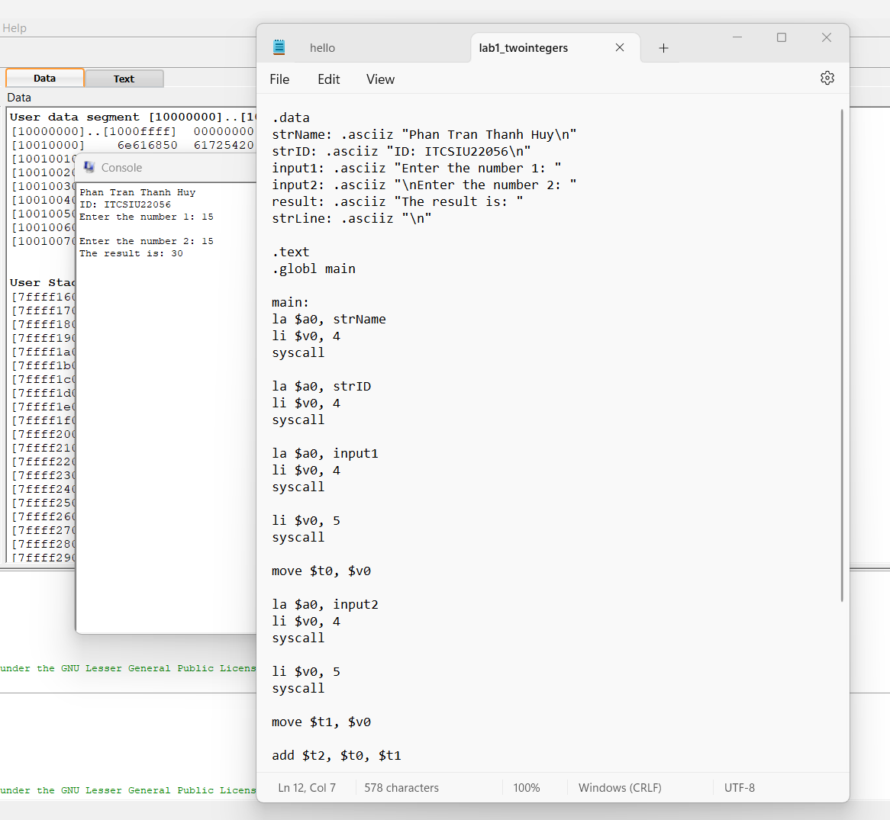

6.

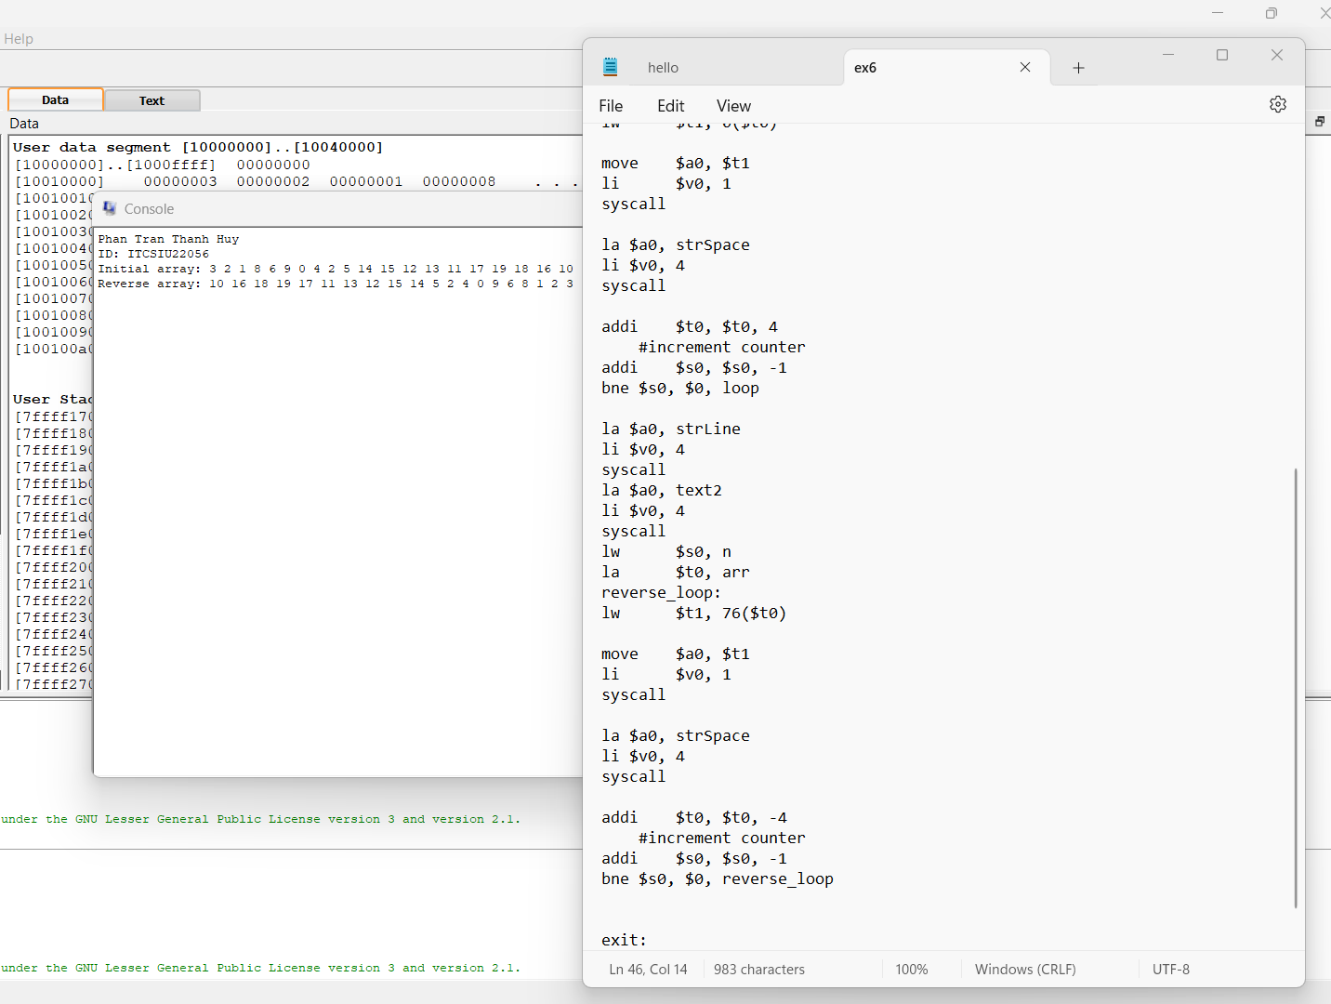

7.

a/

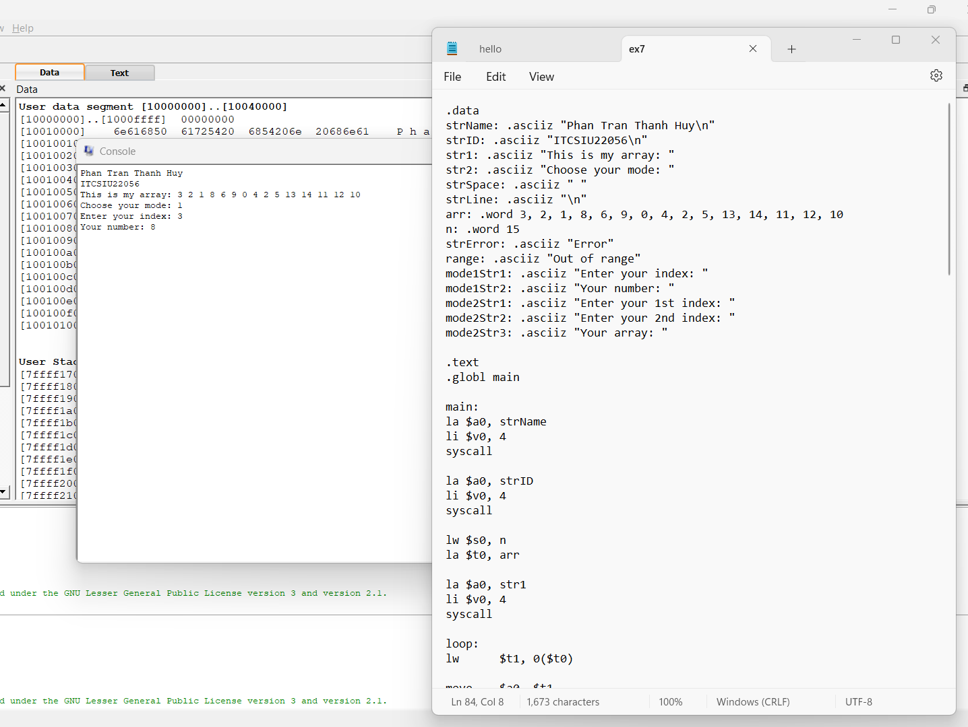

b/

